Chapter 16 Externalities

16.1 Externalities in Our Lives

1) An externality is defined as
A) an additional cost imposed by the government on producers.
B) an additional gain received by consumers from decisions made by the government.
C) a cost or benefit that arises from production and falls on someone other than the producer, or a cost or benefit that arises from consumption and falls on someone other than the consumer.
D) a marginal social cost.
E) the additional amount consumers have to pay to consume an additional amount of a good or service.
Answer: C
Diff: 1 Type: MC
Topic: Externalities in Our Lives

2) An externality is a cost or benefit arising from an economic activity that falls on
A) consumers but not producers.
B) producers but not consumers.
C) consumers or producers.
D) someone other than consumers or producers.
E) foreigners.
Answer: D
Diff: 2 Type: MC
Topic: Externalities in Our Lives

3) Which of the following illustrates the concept of external cost?
A) Bad weather reduces the size of the wheat crop.
B) A reduction in the size of the wheat crop causes income of wheat farmers to fall.
C) Smoking harms the health of the smoker.
D) Smoking harms the health of nearby nonsmokers.
E) Public health services reduce the transmission of disease.
Answer: D
Diff: 2 Type: MC
Topic: Externalities in Our Lives

4) Air pollution generated by a paper mill factory is an example of a
A) positive production externality.
B) positive consumption externality.
C) negative consumption externality.
D) marginal external benefit.
E) negative production externality.
Answer: E
Diff: 1 Type: MC
Topic: Externalities in Our Lives
5) A well-maintained waterfront property that is enjoyed by other property owners is an example of
A) an inefficient allocation of resources.
B) a negative consumption externality.
C) a positive consumption externality.
D) a negative production externality.
E) a positive production externality.
Answer: C
Diff: 2 Type: MC
Topic: Externalities in Our Lives

6) An example of an activity that creates a negative consumption externality is
A) logging, which pollutes rivers.
B) locating beehives next to an orange orchard.
C) smoking, which harms the health of a bystander.
D) a flu vaccination.
E) a sales tax.
Answer: C
Diff: 1 Type: MC
Topic: Externalities in Our Lives

7) Smoking tobacco creates a ________ externality.
A) negative consumption
B) negative production
C) positive consumption
D) positive production
E) marginal
Answer: A
Diff: 1 Type: MC
Topic: Externalities in Our Lives

8) An example of an activity that creates a positive consumption externality is
A) logging, which pollutes rivers.
B) locating beehives next to an orange orchard.
C) smoking, which harms the health of a bystander.
D) a flu vaccination.
E) a noisy party.
Answer: D
Diff: 1 Type: MC
Topic: Externalities in Our Lives

9) A homeowner planting an attractive garden in front of his house creates ________.
A bakery baking bread creates ________.
A) no externality; a positive production externality
B) a positive consumption externality; no externality
C) no externality; no externality
D) a positive consumption externality; a positive production externality
E) a positive production externality; no externality
Answer: D
Diff: 2 Type: MC
Topic: Externalities in Our Lives
Source: MyEconLab
10) A person driving while talking on a cellphone creates ________. A beautiful sunset creates ________.
A) a negative production externality; a positive consumption externality
B) a negative production externality; no externality
C) a negative consumption externality; a positive consumption externality
D) a negative consumption externality; no externality
E) a negative consumption externality; a positive production externality
Answer: D
Diff: 2 Type: MC
Topic: Externalities in Our Lives
Source: MyEconLab

11) An externality is
A) the amount by which price exceeds marginal private cost.
B) the amount by which price exceeds marginal social cost.
C) the effect of government regulation on market price and output.
D) someone who consumes a good without paying for it.
E) a cost or benefit that arises from an activity but affects people not part of the original activity.
Answer: E
Diff: 2 Type: MC
Topic: Externalities in Our Lives

12) A private cost of production is a cost that is borne by the ________ of a good or service.
A social cost of production is a cost that is ________.
A) consumer; borne by the producer and by everyone else on whom the cost falls
B) consumer; not borne by the producer but borne by other people
C) producer; not borne by the producer but borne by other people
D) producer; borne by the producer and by everyone else on whom the cost falls
E) producer; borne by the consumer
Answer: D
Diff: 3 Type: MC
Topic: Externalities in Our Lives
Source: MyEconLab

13) If the marginal private cost of producing one kilowatt of power in British Columbia equals five cents and the marginal social cost of each kilowatt equals nine cents, then the marginal external cost equals ________ per kilowatt.
A) five cents
B) nine cents
C) four cents
D) fourteen cents
E) forty-five cents
Answer: C
Diff: 2 Type: MC
Topic: Externalities in Our Lives
16.2 Negative Externality: Pollution

Use the figure below to answer the following questions.

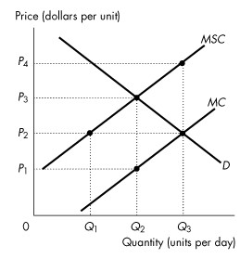
Figure 16.2.1

1) Refer to Figure 16.2.1. The figure shows the marginal private cost curve, the marginal social cost curve and the market demand curve. If the market is unregulated, then the quantity produced is
A) zero.
B) Q1.
C) Q2.
D) Q3.
E) too low.
Answer: D
Diff: 1 Type: MC
Topic: Negative Externality: Pollution

2) Refer to Figure 16.2.1. The figure shows the marginal private cost curve, the marginal social cost curve and the market demand curve. If the market is unregulated, then the price is
A) P1.
B) P4.
C) below P1.
D) P2.
E) P3.
Answer: D
Diff: 1 Type: MC
Topic: Negative Externality: Pollution
3) Refer to Figure 16.2.1. The figure shows the marginal private cost curve, the marginal social cost curve and the market demand curve. If the market is unregulated, then at the equilibrium output the marginal social cost of production is
A) less than the marginal benefit to consumers.
B) greater than the marginal benefit to consumers.
C) equal to the marginal benefit to consumers.
D) equal to the marginal private cost of production.
E) less than the marginal private cost of production.
Answer: B
Diff: 2 Type: MC
Topic: Negative Externality: Pollution

4) Refer to Figure 16.2.1. The figure shows the marginal private cost curve, the marginal social cost curve and the market demand curve. If the market is unregulated, then
A) the quantity produced is efficient but price is too low.
B) the quantity produced is less than the efficient quantity.
C) the quantity produced is greater than the efficient quantity.
D) the quantity produced is efficient but the price is too high.
E) the externality is eliminated.
Answer: C
Diff: 2 Type: MC
Topic: Negative Externality: Pollution

5) Refer to Figure 16.2.1. The figure shows the marginal private cost curve, the marginal social cost curve and the market demand curve. To promote an efficient allocation of resources, the government could impose a constant per unit tax equal to
A) zero.
B) P1.
C) P3 - P1.
D) P4 - P1.
E) P3 - P2.
Answer: C
Diff: 2 Type: MC
Topic: Negative Externality: Pollution

6) Refer to Figure 16.2.1. The figure shows the marginal private cost curve, the marginal social cost curve and the market demand curve. If a constant per unit tax is imposed that generates an efficient allocation of resources, then the quantity produced is
A) zero.
B) Q1.
C) Q2.
D) Q3.
E) greater than Q3.
Answer: C
Diff: 2 Type: MC
Topic: Negative Externality: Pollution
7) Refer to Figure 16.2.1. The figure shows the marginal private cost curve, the marginal social cost curve and the market demand curve. If a constant per unit tax is imposed that generates an efficient allocation of resources, then consumers pay a per unit price of
A) zero.
B) P1.
C) P2.
D) P3.
E) P4.
Answer: D
Diff: 2 Type: MC
Topic: Negative Externality: Pollution

8) Refer to Figure 16.2.1. The figure shows the marginal private cost curve, the marginal social cost curve and the market demand curve. If a constant per unit tax is imposed that generates an efficient allocation of resources, then producers receive a per unit price of
A) zero.
B) P4.
C) P3.
D) P2.
E) P1.
Answer: E
Diff: 2 Type: MC
Topic: Negative Externality: Pollution

9) Effective strategies for addressing the problem of negative externalities include
A) taxing the profit of polluting companies at twice the rate of non-polluting companies.
B) imposing taxes on the activity that generates the pollution.
C) stressing the use of renewable resources.
D) imposing recycling laws.
E) closing down a polluting industry.
Answer: B
Diff: 2 Type: MC
Topic: Negative Externality: Pollution
Use the table below to answer the following questions.

Table 16.2.1

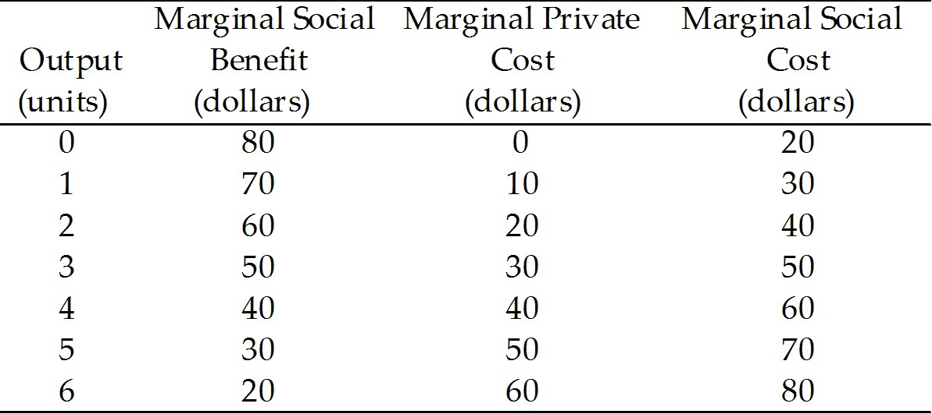

10) Refer to Table 16.2.1. Given in the table are the marginal private cost and the marginal social cost of the production of chemical fertilizer and the marginal social benefit from the consumption of fertilizer. Under these circumstances,
A) there are positive externalities in this market.
B) there are negative externalities in this market, equal to $10 per unit.
C) there are no externalities in this market.
D) not enough information is provided to determine whether or not there are externalities.
E) there are negative externalities in this market, equal to $20 per unit.
Answer: E
Diff: 2 Type: MC
Topic: Negative Externality: Pollution

11) Refer to Table 16.2.1. Given in the table are the marginal private cost and the marginal social cost of the production of chemical fertilizer and the marginal social benefit from the consumption of fertilizer. If the market is unregulated, the quantity produced is
A) 1 unit.
B) 2 units.
C) 3 units.
D) 4 units.
E) 5 units.
Answer: D
Diff: 1 Type: MC
Topic: Negative Externality: Pollution

12) Refer to Table 16.2.1. Given in the table are the marginal private cost and the marginal social cost of the production of chemical fertilizer and the marginal social benefit from the consumption of fertilizer. If the market is unregulated, the market price is
A) $10 a unit.
B) $20 a unit.
C) $30 a unit.
D) $40 a unit.
E) $50 a unit.
Answer: D
Diff: 1 Type: MC
Topic: Negative Externality: Pollution
13) Refer to Table 16.2.1. Given in the table are the marginal private cost and the marginal social cost of the production of chemical fertilizer and the marginal social benefit from the consumption of fertilizer. Assume the market is perfectly competitive. If the market is unregulated, the marginal
A) social cost equals the marginal private benefit.
B) private cost is less than the marginal social benefit.
C) private cost equals the marginal social benefit.
D) social cost equals the marginal private cost.
E) private cost is greater than the marginal social benefit.
Answer: C
Diff: 2 Type: MC
Topic: Negative Externality: Pollution

14) Refer to Table 16.2.1. Given in the table are the marginal private cost and the marginal social cost of the production of chemical fertilizer and the marginal social benefit from the consumption of fertilizer. If the market is unregulated
A) the quantity produced is the efficient quantity.
B) the quantity produced is greater than the efficient quantity.
C) the quantity produced is less than the efficient quantity.
D) marginal external cost is maximized.
E) production is technologically inefficient.
Answer: B
Diff: 2 Type: MC
Topic: Negative Externality: Pollution

15) Refer to Table 16.2.1. Given in the table are the marginal private cost and the marginal social cost of the production of chemical fertilizer and the marginal social benefit from the consumption of fertilizer. If the government decides to correct the externality problem, it could
A) subsidize production by $20 per unit.
B) subsidize production by $10 per unit.
C) provide the good itself.
D) tax production by $10 per unit.
E) tax production by $20 per unit.
Answer: E
Diff: 3 Type: MC
Topic: Negative Externality: Pollution
Use the figure below to answer the following questions.

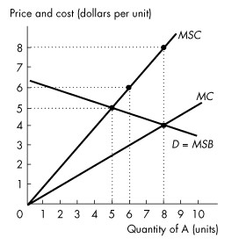
Figure 16.2.2

16) Refer to Figure 16.2.2. This figure shows the demand curve, the marginal private cost curve and the marginal social cost curve of good A. Production of the 6th unit of output generates a marginal external
A) cost of $1.50.
B) cost of $3.
C) cost of $6.
D) benefit of $3.
E) benefit of $6.
Answer: B
Diff: 2 Type: MC
Topic: Negative Externality: Pollution

17) Refer to Figure 16.2.2. This figure shows the demand curve, the marginal private cost curve and the marginal social cost curve of good A. How many units of good A are produced in an unregulated market?
A) 0 units
B) 5 units
C) 6 units
D) 8 units
E) 9 units
Answer: D
Diff: 1 Type: MC
Topic: Negative Externality: Pollution
18) Refer to Figure 16.2.2. This figure shows the demand curve, the marginal private cost curve and the marginal social cost curve of good A. What is the efficient quantity of good A?
A) 0 units
B) 5 units
C) 6 units
D) 8 units
E) impossible to determine without additional information
Answer: B
Diff: 1 Type: MC
Topic: Negative Externality: Pollution

19) In the absence of government intervention, a profit-maximizing firm producing a good with an external cost will produce a quantity at which
A) price is greater than marginal private cost.
B) price is less than marginal revenue.
C) price is less than marginal private cost.
D) price equals marginal private cost.
E) marginal revenue equals marginal social cost.
Answer: D
Diff: 2 Type: MC
Topic: Negative Externality: Pollution

20) When an additional unit of output is produced, the extra cost to society is the
A) average total cost.
B) marginal social cost.
C) marginal private cost.
D) marginal external cost.
E) marginal damage.
Answer: B
Diff: 2 Type: MC
Topic: Negative Externality: Pollution

21) Means of coping with negative externalities include all of the following except
A) implementing abatement technology.
B) patents.
C) property rights.
D) Pigovian taxes.
E) cap-and-trade.
Answer: B
Diff: 1 Type: MC
Topic: Negative Externality: Pollution

22) Which one of the following is a means of coping with a negative externality?
A) emission subsidies
B) patents
C) vouchers
D) Pigovian taxes
E) copyrights
Answer: D
Diff: 1 Type: MC
Topic: Negative Externality: Pollution
23) A battery acid producer pollutes the water upstream from the Polar Bear Club, a swimming club. If transactions costs are low, the quantity of pollution will be efficient
A) only if Ronald Coase is a member of the Polar Bear Club.
B) only if Ronald Coase is not a member of the Polar Bear Club.
C) only if water property rights are assigned to the producer.
D) only if water property rights are assigned to the Polar Bear Club.
E) if water property rights are assigned either to the producer or to the Polar Bear Club.
Answer: E
Diff: 3 Type: MC
Topic: Negative Externality: Pollution

24) The Coase theorem states that
A) patents and copyrights will solve the problem of external costs.
B) taxes will solve the problem of external costs.
C) global warming is hard to solve due to the prisoners' dilemma aspect of the problem.
D) property rights are social arrangements governing ownership, use and disposal of factors of production and goods and services.
E) if property rights are established, and if only a small number of parties are involved, and if transactions costs are low, then private transactions are efficient.
Answer: E
Diff: 2 Type: MC
Topic: Negative Externality: Pollution

Use the table below to answer the following questions.

Table 16.2.2
Chemical Fertilizer Market

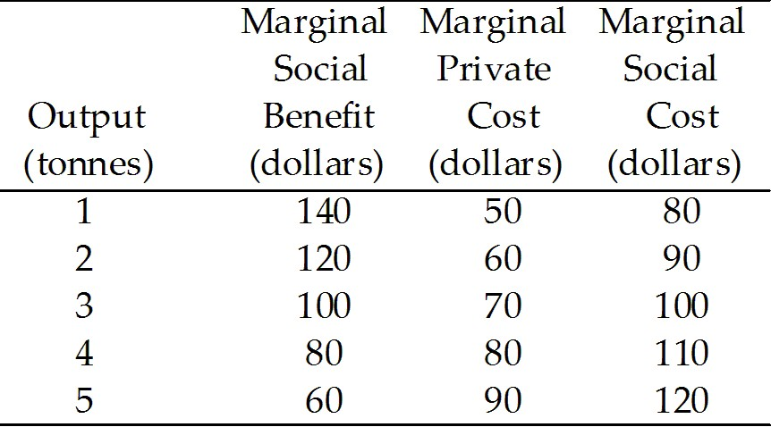

25) Refer to Table 16.2.2. If the fertilizer market is perfectly competitive and unregulated, output (in tonnes) is
A) 1.
B) 2.
C) 3.
D) 4.
E) 5.
Answer: D
Diff: 1 Type: MC
Topic: Negative Externality: Pollution
26) Refer to Table 16.2.2. Fertilizer has a marginal
A) external cost of $100 a tonne.
B) social cost of $100 a tonne.
C) external cost of $30 a tonne.
D) private cost of $30 a tonne.
E) external cost of $0.
Answer: C
Diff: 2 Type: MC
Topic: Negative Externality: Pollution

27) Refer to Table 16.2.2. The efficient output of fertilizer is
A) 1 tonne.
B) 2 tonnes.
C) 3 tonnes.
D) 4 tonnes.
E) 5 tonnes.
Answer: C
Diff: 2 Type: MC
Topic: Negative Externality: Pollution

28) Refer to Table 16.2.2. The Pigovian tax that achieves the efficient quantity of output is
A) $0.
B) $10 a tonne.
C) $20 a tonne.
D) $30 a tonne.
E) $40 a tonne.
Answer: D
Diff: 2 Type: MC
Topic: Negative Externality: Pollution
Use the figure below to answer the following questions.

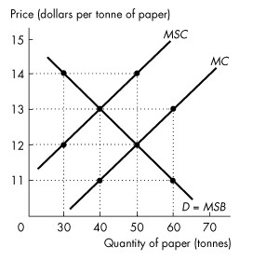
Figure 16.2.3

29) Refer to Figure 16.2.3. The unregulated outcome in the paper market is
A) a quantity of 40 tonnes and a price of $11 a tonne.
B) a quantity of 40 tonnes and a price of $13 a tonne.
C) a quantity of 50 tonnes and a price of $12 a tonne.
D) a quantity of 50 tonnes and a price of $14 a tonne.
E) a quantity of 60 tonnes and a price of $13 a tonne.
Answer: C
Diff: 1 Type: MC
Topic: Negative Externality: Pollution

30) Refer to Figure 16.2.3. In this market there is a marginal external
A) cost of $14 a tonne.
B) cost of $12 a tonne.
C) cost of $2 a tonne.
D) benefit of $2 a tonne.
E) benefit of $12 a tonne.
Answer: C
Diff: 2 Type: MC
Topic: Negative Externality: Pollution

31) Refer to Figure 16.2.3. A tax of ________ per tonne is necessary to achieve the efficient output of ________ tonnes of paper.
A) $14; 50
B) $14; 30
C) $13; 40
D) $2; 50
E) $2; 40
Answer: E
Diff: 2 Type: MC
Topic: Negative Externality: Pollution
32) If negative externalities exist, then in a market with no property rights,
A) MSC = MSB.
B) MSC < MSB.
C) MSC > MSB.
D) MSC = marginal external cost.
E) MC > MSC.
Answer: C
Diff: 2 Type: MC
Topic: Negative Externality: Pollution

33) CoolU has solved its smoking problem by allocating each student 5 smoking permits a day, and allowing trading. This is an example of
A) cap-and-trade.
B) emission charges.
C) the Coase theorem.
D) a pollution tax.
E) a voucher.
Answer: A
Diff: 1 Type: MC
Topic: Negative Externality: Pollution

34) A system of cap-and-trade is used to reduce acid rain caused by emissions from electric power utilities. Which of the following statements is true?
A) Market forces determine both the demand for pollution permits and their supply.
B) Public choice determines both the demand for pollution permits and their supply.
C) Market forces determine the demand for pollution permits, and property rights determine their supply.
D) Property rights determine the demand for pollution permits, and the government determines their supply.
E) Market forces determine the demand for marketable permits, and the government determines their supply.
Answer: E
Diff: 3 Type: MC
Topic: Negative Externality: Pollution

35) The Coase theorem tells us that in the presence of external costs in production,
A) the government must intervene in the market to assure that the efficient level of output is produced.
B) private parties can negotiate to produce the good at a level where marginal willingness to pay for the good by consumers is zero.
C) private parties can never arrive at the efficient solution.
D) then under certain conditions, private parties can arrive at the efficient solution without government involvement.
E) and if transactions costs are high, then only the private sector will be able to produce the efficient amount of the good.
Answer: D
Diff: 2 Type: MC
Topic: Negative Externality: Pollution
36) According to the Coase theorem, if transactions costs are low and property rights exist,
A) negative externalities cause deadweight losses.
B) positive externalities cause deadweight losses.
C) private transactions are efficient.
D) public transactions are efficient.
E) the efficient level of pollution will be zero.
Answer: C
Diff: 3 Type: MC
Topic: Negative Externality: Pollution

37) The Coase theorem will apply only when
A) an individual who is not affected by the externality can negotiate a settlement between the parties imposing the externality and the parties that are harmed by the externality.
B) transactions cost are low.
C) the market is perfectly competitive.
D) the courts can be used to determine the amount of compensation that must be made to the damaged party.
E) the amount of compensation that must be made to the damaged party is small.
Answer: B
Diff: 3 Type: MC
Topic: Negative Externality: Pollution

38) The Coase theorem applies when transactions costs are
A) low and property rights exist.
B) low and property rights do not exist.
C) high and property rights exist.
D) high and property rights do not exist.
E) low and there are no externalities.
Answer: A
Diff: 3 Type: MC
Topic: Negative Externality: Pollution

39) The marginal private cost curve (MC) is a positively-sloped straight line starting at the origin. If marginal external cost increases as output increases, then the marginal social cost curve is a positively-sloped straight line
A) parallel to and above the MC curve.
B) parallel to and below the MC curve.
C) starting at the origin, above the MC curve, and with a slope greater than the MC curve.
D) starting at the origin, below the MC curve, and with a slope less than the MC curve.
E) starting above the origin, with a slope less than the MC curve.
Answer: C
Diff: 2 Type: MC
Topic: Negative Externality: Pollution
40) One way to solve negative externality problems is
A) to organize a limited boycott of the products.
B) subsidize the externalities.
C) eliminate transactions costs when property rights are not legally established.
D) issue pollution permits to polluting firms and establish a system of cap-and-trade.
E) establish and enforce patents and copyrights.
Answer: D
Diff: 2 Type: MC
Topic: Negative Externality: Pollution

41) Pollution occurs when lumber is produced. If the lumber market is unregulated, there would be
A) overproduction of lumber compared to the efficient amount.
B) underproduction of lumber compared to the efficient amount.
C) sometimes overproduction and sometimes underproduction of lumber compared to the efficient amount.
D) an external benefit from producing lumber.
E) no deadweight loss from production.
Answer: A
Diff: 1 Type: MC
Topic: Negative Externality: Pollution

42) When the marginal social cost of the production of Good A is greater than the marginal private cost of the production of Good A, then
A) a competitive, unregulated market produces less than the efficient quantity of Good A.
B) a competitive, unregulated market produces the efficient quantity of Good A.
C) a competitive, unregulated market produces more than the efficient quantity of Good A.
D) the government should levy a tax on the production of Good A that is equal to the horizontal distance between the two marginal cost curves.
E) a competitive, unregulated market does not create a deadweight loss.
Answer: C
Diff: 2 Type: MC
Topic: Negative Externality: Pollution

43) When the production of a good has an external cost, the
A) marginal social cost curve lies below the marginal private cost curve.
B) marginal social benefit curve lies above the marginal private benefit curve.
C) equilibrium quantity in an unregulated, competitive market has a marginal social cost greater than the marginal social benefit.
D) equilibrium quantity in an unregulated, competitive market has a marginal social cost less than the marginal social benefit.
E) good should not be produced.
Answer: C
Diff: 3 Type: MC
Topic: Negative Externality: Pollution
44) Consider some type of industrial pollution that generates air pollution. This industry, if left unregulated, will produce
A) more than the efficient level because they will ignore the marginal external costs.
B) the efficient level of output.
C) less than the efficient level because they will ignore the marginal external costs.
D) less than the efficient level because they will ignore the marginal external benefits.
E) more than the efficient level because they will ignore the marginal external benefits.
Answer: A
Diff: 2 Type: MC
Topic: Negative Externality: Pollution

Use the table below to answer the following question.

Table 16.2.3

Price | Quantity | Marginal cost
(cents per kilowatt) | (kilowatts per day) | (cents per kilowatt)
4 | 500 | 10
8 | 400 | 8
12 | 300 | 6
16 | 200 | 4
20 | 100 | 2

45) Refer to Table 16.2.3. The first two columns of the table show the demand schedule for electricity from a coal burning utility; the second and third columns show the utility's cost of producing electricity.
The marginal external cost of the pollution created is equal to the marginal cost.
Suppose the government levies a pollution tax such that the utility generates the efficient quantity of electricity. The pollution tax is ________ cents a kilowatt hour.
A) 2
B) 4
C) 6
D) 8
E) 10
Answer: C
Diff: 2 Type: MC
Topic: Negative Externality: Pollution
Source: MyEconLab
46) Betty and Anna work at the same office in Calgary. They both must attend a meeting in Edmonton, and they have decided to drive to the meeting together. Betty is a cigarette smoker and her marginal benefit from smoking one package of cigarettes a day is $40. Cigarettes are $6 a pack. Anna dislikes cigarette smoke and her marginal benefit from a smoke-free environment is $50 a day. If Betty drives her car with Anna as a passenger, ________. If Anna drives her car with Betty as a passenger, ________.
A) Anna will offer Betty an amount between $34 and $50 and Betty will not smoke; Betty does not smoke because Betty will not offer Anna a high enough price to be allowed to smoke.
B) Betty will smoke because she owns the property rights in the car; Betty does not smoke because Betty will not offer Anna a high enough price to be allowed to smoke.
C) Betty will smoke because she owns the property rights in the car; Betty will offer Anna $51 and Betty will smoke.
D) Anna will offer Betty an amount between $34 and $50 and Betty will not smoke; Betty will offer Anna $51 and Betty will smoke.
E) Betty will smoke because she is the car owner; Betty will offer Anna an amount between $34 and $50 and Betty will smoke.
Answer: A
Diff: 3 Type: MC
Topic: Negative Externality: Pollution
Source: MyEconLab

47) If the production of a good creates pollution, then the
A) marginal social benefit curve lies above the marginal private benefit curve.
B) marginal social cost curve lies above the marginal private cost curve.
C) marginal social benefit curve lies below the marginal private benefit curve.
D) marginal social cost curve lies below the marginal private cost curve.
E) marginal social benefit curve intersects the marginal private cost curve at the efficient quantity.
Answer: B
Diff: 2 Type: MC
Topic: Negative Externality: Pollution

48) When Good A is produced, pollution is also produced. When the marginal social cost of production of Good A equals marginal social benefit from Good A, then
I. there is no pollution.
II. resources are used efficiently.
A) I only
B) II only
C) neither I nor II
D) both I and II
E) sometimes I and sometimes II, but never both simultaneously
Answer: B
Diff: 2 Type: MC
Topic: Negative Externality: Pollution
49) Producing paper creates pollution. There is no externality in the consumption of paper. The efficient quantity of paper produced occurs when the
A) marginal social benefit from paper is equal to zero.
B) marginal social cost of the pollution from making paper is equal to zero.
C) marginal private cost of the pollution from making paper is equal to zero.
D) marginal private cost of paper equals the marginal private benefit from paper.
E) marginal social benefit from paper is equal to the marginal social cost of paper.
Answer: E
Diff: 3 Type: MC
Topic: Negative Externality: Pollution

50) A chemical factory and a fishing club share a lake. Producing chemicals creates water pollution that harms the fish. Initially the lake is owned by no one. Keeping in mind the Coase theorem, suppose transactions costs are low and the chemical factory is given ownership of the lake. Compared to the situation with no property rights, the quantity of chemicals produced
A) decreases.
B) stays the same.
C) increases.
D) changes but the direction of the change is unknown.
E) decreases only if the marginal external benefit decreases.
Answer: A
Diff: 2 Type: MC
Topic: Negative Externality: Pollution

51) A production technology that reduces or prevents pollution is
A) anti-pollution technology.
B) Coase technology.
C) abatement technology.
D) cap-and-trade technology.
E) inefficient.
Answer: C
Diff: 1 Type: MC
Topic: Negative Externality: Pollution

52) The government department charged with monitoring and protecting the environment is
A) Protection Canada.
B) Revenue Canada.
C) Environment Canada.
D) Industry Canada.
E) the EPA.
Answer: C
Diff: 1 Type: MC
Topic: Negative Externality: Pollution
53) Environment Canada was created in
A) 1971.
B) 1961.
C) 1981.
D) 1991.
E) 2001.
Answer: A
Diff: 1 Type: MC
Topic: Negative Externality: Pollution

54) Choose the statement that is incorrect.
A) Between 2008 and 2012, carbon emissions in British Columbia remained constant.
B) As of 2012, British Columbia applies a carbon tax of $30 per tonne of carbon emitted.
C) British Columbia's carbon tax is revenue-neutral.
D) Australia has a carbon tax.
E) A high gas tax in the United Kingdom cuts carbon emissions by inducing people to drive smaller cars and to drive less.
Answer: A
Diff: 1 Type: MC
Topic: Negative Externality: Pollution

55) Choose the statement that is incorrect.
A) Firms that have a high marginal abatement cost sell pollution permits.
B) A cap is an upper limit.
C) A cap is a pollution quota.
D) A government that uses cap-and-trade must first estimate the efficient quantity of pollution and set the overall cap at that level.
E) The government solves the problem of allocating the cap by making an initial distribution of the cap across firms and allowing them to trade in a market for pollution permits.
Answer: A
Diff: 2 Type: MC
Topic: Negative Externality: Pollution

Use the information below to answer the following question.

Fact 16.2.1 Global Solutions for Local Gridlock
Gridlock costs Toronto $6 billion a year, with average commutes of 80 minutes. By 2013, an additional 27 minutes will be added to the daily grind. Civic leaders are looking at road tolls, a regional gas tax, and parking levies.
Source: Toronto Star, June 24, 2011

56) Refer to Figure 16.2.1. Toll roads, a regional gas tax, and parking levies ________ make Toronto streets less congested because ________.
A) will not; drivers will switch to using public transport only if TTC prices fall
B) will not; additional charges on Toronto's motorists will not change driving habits
C) will; motorists will consider the external benefit from driving in Toronto
D) will; motorists will consider the external cost of driving in Toronto
E) will not; construction on Toronto's streets always results in congestion
Answer: D
Diff: 2 Type: MC
Topic: Negative Externality: Pollution
Source: MyEconLab
16.3 Positive Externality: Knowledge

1) The marginal private benefit curve (MB) is a negatively-sloped straight line. If marginal external benefit decreases as output increases, the marginal social benefit curve is a negatively-sloped straight line
A) parallel to and above the MB curve.
B) parallel to and below the MB curve.
C) above the MB curve and steeper than the MB curve.
D) above the MB curve and flatter than the MB curve.
E) below the MB curve and flatter than the MB curve.
Answer: C
Diff: 1 Type: MC
Topic: Positive Externality: Knowledge

Use the figure below to answer the following questions.

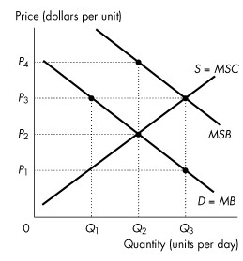
Figure 16.3.1

2) Refer to Figure 16.3.1. The figure shows the marginal private benefit curve, the marginal social benefit curve, and the market supply curve. If production is left to the private market, then the quantity produced is
A) zero.
B) Q1.
C) Q2.
D) Q3.
E) between 0 and Q1.
Answer: C
Diff: 1 Type: MC
Topic: Positive Externality: Knowledge
3) Refer to Figure 16.3.1. The figure shows the marginal private benefit curve, the marginal social benefit curve, and the market supply curve. If production is left to the private market, then the price is
A) P1.
B) P3.
C) P2.
D) greater than P4.
E) P4.
Answer: C
Diff: 1 Type: MC
Topic: Positive Externality: Knowledge

4) Refer to Figure 16.3.1. The figure shows the marginal private benefit curve, the marginal social benefit curve, and the market supply curve. If production is left to the private market, then at the equilibrium quantity the marginal social benefit from consumption is
A) less than the marginal cost to producers.
B) less than the marginal social cost of production.
C) equal to the marginal cost to producers.
D) equal to the marginal private benefit from consumption.
E) greater than the marginal cost to producers.
Answer: E
Diff: 2 Type: MC
Topic: Positive Externality: Knowledge

5) Refer to Figure 16.3.1. The figure shows the marginal private benefit curve, the marginal social benefit curve, and the market supply curve. If production is left to the private market, then
A) the quantity produced is less than the efficient quantity.
B) the quantity produced is greater than the efficient quantity.
C) price is greater than marginal social benefit quantity.
D) the marginal cost curve is horizontal.
E) the quantity produced is zero.
Answer: A
Diff: 2 Type: MC
Topic: Positive Externality: Knowledge

6) Refer to Figure 16.3.1. The figure shows the marginal private benefit curve, the marginal social benefit curve, and the market supply curve. To promote an efficient quantity the government could grant a subsidy equal to
A) zero.
B) P1.
C) P3 - P1.
D) P4 - P1.
E) P2 - P1.
Answer: C
Diff: 2 Type: MC
Topic: Positive Externality: Knowledge
7) Refer to Figure 16.3.1. The figure shows the marginal private benefit curve, the marginal social benefit curve, and the market supply curve. If a subsidy is granted that generates an efficient quantity, then the quantity produced is
A) zero.
B) Q1.
C) Q2.
D) Q3.
E) greater than Q3.
Answer: D
Diff: 2 Type: MC
Topic: Positive Externality: Knowledge

8) Refer to Figure 16.3.1. The figure shows the marginal private benefit curve, the marginal social benefit curve, and the market supply curve. If a voucher is given to consumers that generates an efficient outcome, then consumers pay
A) zero.
B) P1 per unit.
C) P2 per unit.
D) P3 per unit.
E) P4 per unit.
Answer: B
Diff: 3 Type: MC
Topic: Positive Externality: Knowledge

9) Refer to Figure 16.3.1. The figure shows the marginal private benefit curve, the marginal social benefit curve, and the market supply curve. If a voucher is given to consumers that generates an efficient outcome, then producers receive a price of
A) zero.
B) P1 per unit.
C) P2 per unit.
D) P3 per unit.
E) P4 per unit.
Answer: D
Diff: 3 Type: MC
Topic: Positive Externality: Knowledge
Use the table below to answer the following questions.

Table 16.3.1

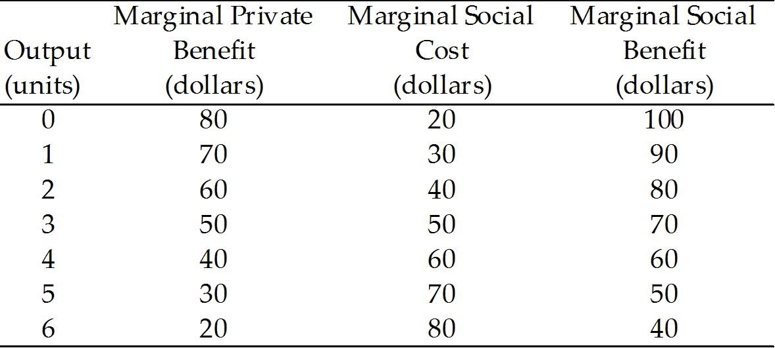

10) Refer to Table 16.3.1. The table shows marginal private benefit and the marginal social benefit from the consumption of chemical fertilizer and the marginal social cost of the production of fertilizer. Choose the correct statement.
A) The marginal external benefit is $20 per unit.
B) The marginal external cost is $10 per unit.
C) There are no externalities associated with this market.
D) The marginal external benefit is $10 per unit.
E) There is not enough information provided to determine whether or not there are externalities.
Answer: A
Diff: 2 Type: MC
Topic: Positive Externality: Knowledge

11) Refer to Table 16.3.1. The table shows marginal private benefit and the marginal social benefit from the consumption of chemical fertilizer and the marginal social cost of the production of fertilizer. If production is left to the private market, the quantity produced is
A) 1 unit.
B) 2 units.
C) 3 units.
D) 4 units.
E) 5 units.
Answer: C
Diff: 2 Type: MC
Topic: Positive Externality: Knowledge

12) Refer to Table 16.3.1. The table shows marginal private benefit and the marginal social benefit from the consumption of chemical fertilizer and the marginal social cost of the production of fertilizer. If production is left to the private market, the market price is
A) $70 a unit.
B) $60 a unit.
C) $50 a unit.
D) $40 a unit.
E) $30 a unit.
Answer: C
Diff: 2 Type: MC
Topic: Positive Externality: Knowledge
13) Refer to Table 16.3.1. The table shows marginal private benefit and the marginal social benefit from the consumption of chemical fertilizer and the marginal social cost of the production of fertilizer. If production is left to the private market, then at the profit-maximizing output level, marginal
A) social cost equals marginal private benefit.
B) private cost is less than marginal private benefit.
C) social cost is less than marginal private benefit.
D) social cost is greater than marginal private benefit.
E) social benefit is less than marginal private benefit.
Answer: A
Diff: 2 Type: MC
Topic: Positive Externality: Knowledge

14) Refer to Table 16.3.1. The table shows marginal private benefit and the marginal social benefit from the consumption of chemical fertilizer and the marginal social cost of the production of fertilizer. If production is left to the private market, then
A) an efficient quantity is produced.
B) imposing a tax leads to production of the efficient quantity.
C) too much fertilizer is produced.
D) a system of pollution permits leads to production of the efficient quantity.
E) an inefficient quantity is produced.
Answer: E
Diff: 2 Type: MC
Topic: Positive Externality: Knowledge

15) Refer to Table 16.3.1. The table shows marginal private benefit and the marginal social benefit from the consumption of chemical fertilizer and the marginal social cost of the production of fertilizer. An efficient quantity is produced if the government
A) subsidizes production by $20 per unit.
B) subsidizes production by $10 per unit.
C) provides vouchers for consumption of $20 per unit.
D) taxes production by $10 per unit.
E) either A or C.
Answer: E
Diff: 3 Type: MC
Topic: Positive Externality: Knowledge
Use the figure below to answer the following questions.

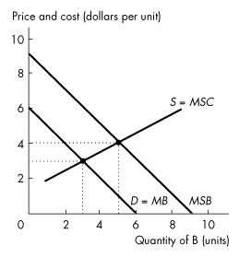
Figure 16.3.2

16) Refer to Figure 16.3.2. The figure shows the market for good B. How many units of good B are produced and consumed in an unregulated market?
A) 0 units
B) 3 units
C) 5 units
D) 6 units
E) 9 units
Answer: B
Diff: 1 Type: MC
Topic: Positive Externality: Knowledge

17) Refer to Figure 16.3.2.The figure shows the market for good B. What is the efficient quantity of good B?
A) 0 units
B) 3 units
C) 5 units
D) 6 units
E) 9 units
Answer: C
Diff: 2 Type: MC
Topic: Positive Externality: Knowledge
18) In Figure 16.3.2. The figure shows the market for good B. Which of the following government policies creates an efficient outcome?
A) Tax the production of B by $3 per unit.
B) Tax the production of B by $4 per unit.
C) Provide vouchers for consumption of B of $1 per unit.
D) Provide vouchers for consumption of B of $3 per unit.
E) Provide vouchers for consumption of B of $4 per unit.
Answer: D
Diff: 2 Type: MC
Topic: Positive Externality: Knowledge

19) Refer to Figure 16.3.2. The figure shows the market for good B. Under public production, consumers pay ________ for each unit of B.
A) zero
B) $1
C) $2
D) $3
E) $4
Answer: B
Diff: 3 Type: MC
Topic: Positive Externality: Knowledge

20) The devices the government can use to achieve a more efficient allocation of resources in the presence of external benefits include all of the following except
A) subsidies.
B) patents.
C) copyrights.
D) taxes.
E) vouchers.
Answer: D
Diff: 2 Type: MC
Topic: Positive Externality: Knowledge

21) The devices the government can use to achieve a more efficient allocation of resources in the presence of external benefits include all of the following except
A) intellectual property rights.
B) subsidies.
C) public production.
D) pollution permits.
E) patents.
Answer: D
Diff: 2 Type: MC
Topic: Positive Externality: Knowledge
22) Complete the following sentence. Knowledge
A) generates external benefits.
B) generates external costs.
C) displays diminishing marginal benefit.
D) is encouraged by intellectual property rights.
E) A and D are correct.
Answer: E
Diff: 2 Type: MC
Topic: Positive Externality: Knowledge

23) Which of the following is least likely to display diminishing marginal benefit?
A) land
B) labour
C) capital
D) entrepreneurship
E) knowledge
Answer: E
Diff: 2 Type: MC
Topic: Positive Externality: Knowledge

24) If positive externalities exist and production is left to the private market, then at the quantity produced,
A) MSC = MSB.
B) MSC < MSB.
C) MSC > MSB.
D) MSB = marginal external benefit.
E) MSB = 1/MSC.
Answer: B
Diff: 2 Type: MC
Topic: Positive Externality: Knowledge

25) Choose the incorrect statement.
A) A patent encourages invention.
B) A patent encourages innovation.
C) A patent has an economic cost.
D) A patent creates a negative externality.
E) A patent produces a monopoly.
Answer: D
Diff: 2 Type: MC
Topic: Positive Externality: Knowledge

26) Three ways governments can encourage production of goods with external benefits are
A) private subsidies, pollution permits, and intellectual property rights.
B) private subsidies, pollution permits, and vouchers.
C) intellectual property rights, pollution permits, and vouchers.
D) taxes, emission charges, and pollution permits.
E) private subsidies, vouchers, and intellectual property rights.
Answer: E
Diff: 3 Type: MC
Topic: Positive Externality: Knowledge
27) The economic benefit of a patent or copyright must be balanced against
A) the external benefit from the good.
B) the external cost of the good.
C) the marginal private cost of the good.
D) the cost of temporary monopoly.
E) the marginal social cost of the good.
Answer: D
Diff: 3 Type: MC
Topic: Positive Externality: Knowledge

28) In recent years, as provincial governments attempt to balance their budgets, they have increased tuition fees considerably. This increase will likely result in
A) more students.
B) fewer students.
C) underprovision of education compared to the efficient level.
D) overprovision of education compared to the efficient level.
E) B and C.
Answer: E
Diff: 2 Type: MC
Topic: Positive Externality: Knowledge

29) A patent is an example of
A) a subsidy.
B) a pollution permit.
C) a voucher.
D) a tax.
E) a legal device for creating property rights.
Answer: E
Diff: 1 Type: MC
Topic: Positive Externality: Knowledge

30) To increase efficiency,
A) taxes are used to overcome both external benefits and external costs.
B) subsidies are used to overcome both external benefits and external costs.
C) subsidies are used to overcome external benefits, and taxes to overcome external costs.
D) taxes are used to overcome external benefits, and subsidies to overcome external costs.
E) public provision used to overcome external benefits, and vouchers to overcome external costs.
Answer: C
Diff: 2 Type: MC
Topic: Positive Externality: Knowledge

31) A market economy tends to ________ goods with negative externalities and ________ goods with positive externalities.
A) overproduce; overproduce
B) overproduce; underproduce
C) underproduce; overproduce
D) underproduce; underproduce
E) produce; consume
Answer: B
Diff: 2 Type: MC
Topic: Positive Externality: Knowledge
32) The outcome from a voucher scheme is efficient when the government makes the value of the voucher equal to
A) marginal external cost.
B) marginal external benefit.
C) private external cost.
D) private external benefit.
E) marginal social cost.
Answer: B
Diff: 1 Type: MC
Topic: Positive Externality: Knowledge

33) A voucher can eliminate the deadweight loss and lead to an efficient outcome if the value of the voucher equals the ________ of the good.
A) marginal external benefit
B) marginal social benefit
C) marginal private benefit
D) marginal social cost
E) marginal external cost
Answer: A
Diff: 1 Type: MC
Topic: Positive Externality: Knowledge
Use the figure below to answer the following questions.

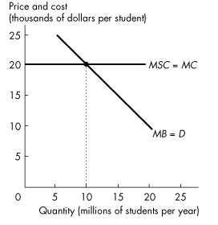
Figure 16.3.3

34) Refer to Figure 16.3.3. The figure shows the marginal private benefit and marginal social cost of a university education. If society's external benefit from university graduates is $10,000 each, then the
A) marginal social cost curve lies $10,000 to the left of the private marginal benefit curve.
B) marginal social cost curve lies $10,000 to the right of the private marginal benefit curve.
C) marginal social benefit curve lies $10,000 below the private marginal benefit curve.
D) marginal social benefit curve lies $10,000 above the private marginal benefit curve.
E) marginal social benefit curve is horizontal.
Answer: D
Diff: 2 Type: MC
Topic: Positive Externality: Knowledge

35) Refer to Figure 16.3.3. The figure shows the marginal private benefit and marginal social cost of a university education. Society's external benefit from university graduates is $10,000 each. With no subsidy,
A) no students go to university.
B) less than 10 million students go to university.
C) 10 million students go to university.
D) more than 10 million students go to university.
E) the market is efficient.
Answer: C
Diff: 2 Type: MC
Topic: Positive Externality: Knowledge
36) Refer to Figure 16.3.3. The figure shows the marginal private benefit and marginal social cost of a university education. If society's external benefit from university graduates is $10,000 each, then
A) a subsidy of $10,000 per student paid to the universities achieves efficiency.
B) a tax of $10,000 per student imposed on the universities achieves efficiency.
C) 10 million students per year is the efficient number students.
D) a subsidy of $20,000 per student paid to the universities achieves efficiency.
E) a tax of $5,000 per student paid by taxpayers achieves efficiency.
Answer: A
Diff: 2 Type: MC
Topic: Positive Externality: Knowledge

37) All of the following statements are correct except
A) knowledge about one process spills over into other segments of the economy.
B) additional knowledge makes people more productive, and there seems to be no tendency for the additional productivity from additional knowledge to diminish.
C) knowledge has no external benefit.
D) knowledge might be an exception to the principle of diminishing marginal benefit.
E) it is necessary to use public policies to ensure that those who develop new ideas have incentives to encourage an efficient level of effort.
Answer: C
Diff: 2 Type: MC
Topic: Positive Externality: Knowledge
Source: MyEconLab

38) Research and development ________ create an external benefit. With no intervention, we produce too ________ research and development.
A) does; little
B) does not; much
C) does not; little
D) does; much
E) none of the above. Research and development create an external cost.
Answer: A
Diff: 2 Type: MC
Topic: Positive Externality: Knowledge
Source: MyEconLab

39) Researchers produce the efficient quantity of research and development if they receive a voucher equal to the marginal ________ benefit, or a subsidy equal to the marginal ________ benefit.
Patents and copyrights ________ result in an efficient amount of research and development.
A) social; social; cannot
B) social; social; can
C) external; external; cannot
D) external; external; can
E) external; social; can
Answer: D
Diff: 3 Type: MC
Topic: Positive Externality: Knowledge
Source: MyEconLab
40) Most governments subsidize basic education because
A) there are external costs associated with well-educated citizens.
B) the marginal social benefit from education is greater than the marginal private benefit.
C) of the existence of private schools.
D) the marginal social cost of education is greater than the marginal private cost.
E) otherwise too many students will receive educations.
Answer: B
Diff: 2 Type: MC
Topic: Positive Externality: Knowledge

41) Governments use subsidies
A) as a means of increasing government spending.
B) when they want to increase taxes.
C) to achieve an efficient outcome in a market with external costs.
D) to achieve an efficient outcome in a market with external benefits.
E) and pollution permits to achieve an efficient outcome in markets with external benefits.
Answer: D
Diff: 2 Type: MC
Topic: Positive Externality: Knowledge

42) A private subsidy on a good
A) is similar to a tax because it decreases the production of the good being subsidized.
B) increases demand for the good.
C) punishes those who consume or produce the subsidized good.
D) has no effect on the quantity of the good produced.
E) increases production of that good.
Answer: E
Diff: 1 Type: MC
Topic: Positive Externality: Knowledge

43) A voucher can eliminate the deadweight loss and lead to an efficient outcome if the value of the voucher equals the ________ of the good.
A) marginal external cost
B) marginal social benefit
C) marginal private benefit
D) marginal social cost
E) marginal external benefit
Answer: E
Diff: 2 Type: MC
Topic: Positive Externality: Knowledge

44) Suppose that recycling rubber for running shoes creates an external benefit of $2.00 per tonne of rubber. There are no external costs. The efficient amount of rubber will be recycled when the government creates a
A) subsidy of more than $2.00 per tonne of rubber.
B) subsidy of $2.00 per tonne of rubber.
C) tax of more than $2.00 per tonne of rubber.
D) tax of $2.00 per tonne of rubber.
E) voucher valued at $2.10 a tonne of rubber.
Answer: B
Diff: 2 Type: MC
Topic: Positive Externality: Knowledge
45) If the marginal social benefit of a good equals the marginal private benefit of the good, then the marginal external benefit of the good
A) equals the marginal private cost.
B) is zero.
C) equals the marginal social cost.
D) equals the marginal social benefit.
E) is increasing.
Answer: B
Diff: 2 Type: MC
Topic: Positive Externality: Knowledge

46) When individuals make decisions about how much schooling to obtain, they
A) do not consider the personal benefits that education creates.
B) overvalue the personal benefits that education creates.
C) overvalue the external benefits that education creates.
D) do not consider the external benefits that education creates.
E) set marginal social benefit equal to tuition.
Answer: D
Diff: 1 Type: MC
Topic: Positive Externality: Knowledge

47) Post-secondary education in Canada is subsidized. This fact suggests that
i. less than the efficient amount of education would be provided by an unregulated market.
ii. the marginal private benefit from education equals the marginal social benefit from education.
iii. post-secondary education has no externalities.
Which statements are correct?
A) i only
B) ii only
C) iii only
D) i and ii only
E) i, ii, and iii
Answer: A
Diff: 3 Type: MC
Topic: Positive Externality: Knowledge

